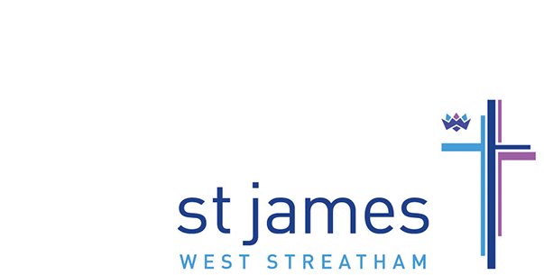

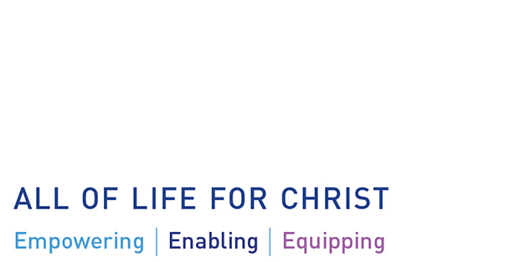
PCC Digest January 2020
The PCC of St James met recently and this is a summary of the discussions and decisions.
Finances
The PCC approved the church budget for 2020 with a planned deficit of almost £25,000. This is mainly to pay for the Building for the Kingdom feasibility study and will be covered by reserve funds and appropriate restricted and designated funds. It was noted that last year saw a slight decrease in regular donations and whilst we want to encourage us all to consider increasing our giving we must also recognise that many are already giving sacrificially for which we are truly grateful to God.
We are exploring the benefits of installing ‘contactless’ payment facilities in church and will make a decision as to whether St James should introduce this later this year.

Building for the Kingdom
After a long and rigorous process, we are about to sign a contract with JBKS, a Christian architectural practice based in Oxfordshire, to undertake a feasibility study showing us the various options and possibilities for developing our site and buildings. JBKS will be consulting with the PCC and various groups along the way and hope to finish their work by the summer.

Staffing
The PCC welcomed new Church Manager, Oliva-Mae Alman, to her first meeting and heard that she has settled in well to her role having started work on 2nd January.

Christmas Review
The PCC spent some time reviewing the Christmas services and activities. Highlights were the Children’s Carol Service, Carols by Candlelight and the Furzedown Nativity. It was noted that we need to think more strategically about follow-up and how we might encourage visitors to come back for more!

PCC+ Away Day
This will take place on Saturday 19th September 2020 at Holy Trinity, Redhill. The focus for the day will be reviewing and renewing our 2020 Vision Mission Action Plan now that we have reached 2020.

Safeguarding
The Diocese has issued a new edition of A Safe Church, the safeguarding policy adopted by all churches in Southwark. There is an edition on their web site and a hard copy will be placed in the church office for reference.
The diocese is also undertaking a Past Cases Review seeking to unearth any historic safeguarding cases involving church officers which were not properly dealt with. St James has been asked to respond by mid-February.

The next meeting of the PCC will be on 16th March. If you have any issues you would like to be considered for inclusion on the agenda please use the PCC Suggestion Box on the Information Desk or email the church office at admin_stjameschurch@btinternet.com

